Project name: NEST E-Commerce Website
The goal is to build NEST as a professional, responsive e-commerce website using only HTML5, CSS3, Bootstrap CSS, vanilla JavaScript, and MongoDB. There will be no React, Angular, Vue, Python, Flask, Node.js, Express, or other frontend frameworks or backend languages.
One technical point must be considered from the beginning: HTML, CSS, and browser JavaScript cannot securely connect directly to MongoDB by themselves. MongoDB needs a secure server-side or managed data-access layer. Since you don't want another backend technology, the project must use a compatible managed JavaScript-accessible service if one is available and suitable; otherwise, database-backed features will require relaxing that restriction. The project must not expose MongoDB credentials in frontend files.
1. Project overview
NEST will provide two main interfaces:
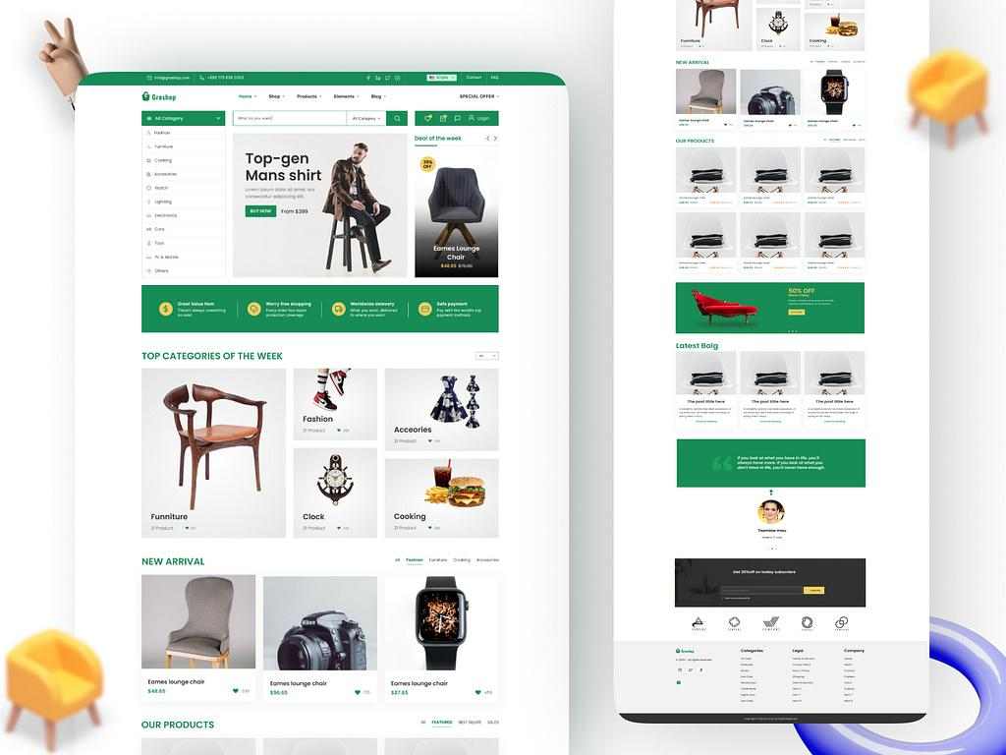
Customer storefront
A shopping experience for browsing products, managing a cart, placing orders, and viewing order history.
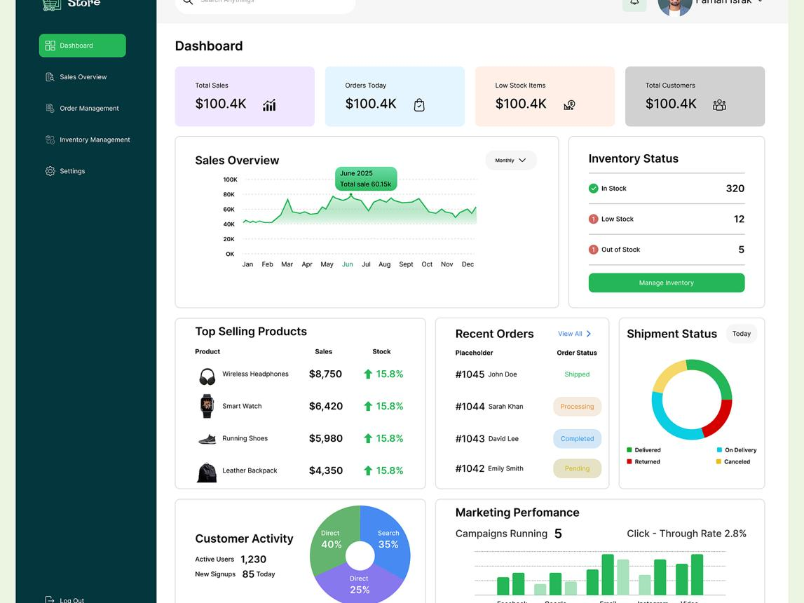
Admin panel
A restricted dashboard for managing products, categories, inventory, customers, discounts, and orders.
Main objectives
- Create a professional online shopping platform.
- Make the interface responsive across different screen sizes.
- Provide product search, filters, categories, and sorting.
- Allow customers to manage their cart, wishlist, and orders.
- Provide an admin interface for managing the store.
- Store application data in MongoDB through a secure, supported connection.
- Keep the code readable, modular, and suitable for a B.Tech CSE project.
2. Technology and tools
Technology | Purpose
HTML5 | Page structure and forms
CSS3 | Custom styling, layouts, animations, and responsive design
Bootstrap CSS | Grid system, utility classes, and UI components
Vanilla JavaScript | Shopping logic, validation, DOM updates, and API integration
MongoDB Atlas | Cloud database
VS Code | Code editor
Git and GitHub | Version control and source code storage
Static hosting | Publish the frontend
Bootstrap will be used as a CSS/UI toolkit, not as a JavaScript application framework. Custom interactions can be written in plain JavaScript.
3. Customer website modules
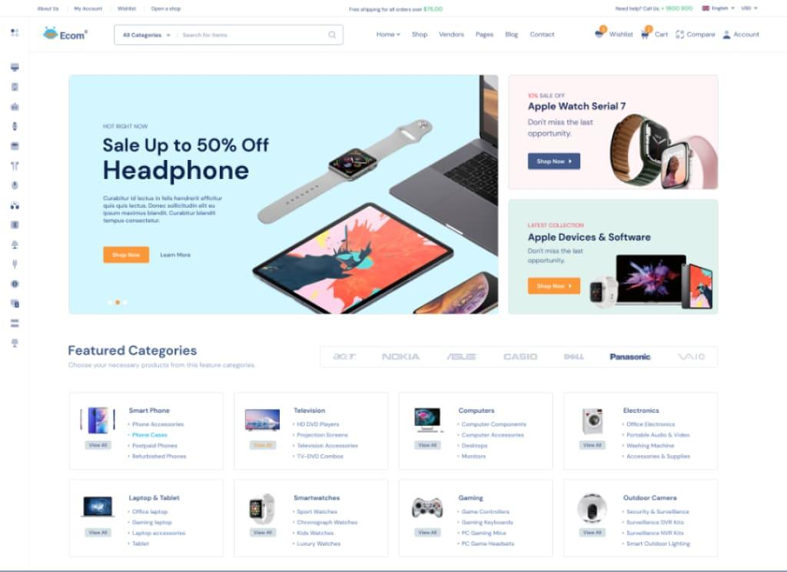
Module 1 — Home page
- NEST logo, navigation, and search bar.
- Hero banner and promotional offers.
- Featured products, new arrivals, and best sellers.
- Category shortcuts and product recommendations.
- Newsletter section and footer.
Module 2 — Shop and categories
- All products and category-specific listings.
- Search by product name or keyword.
- Filter by category, price, rating, and availability.
- Sort by price, newest, popularity, or rating.
- Pagination or a load-more button.
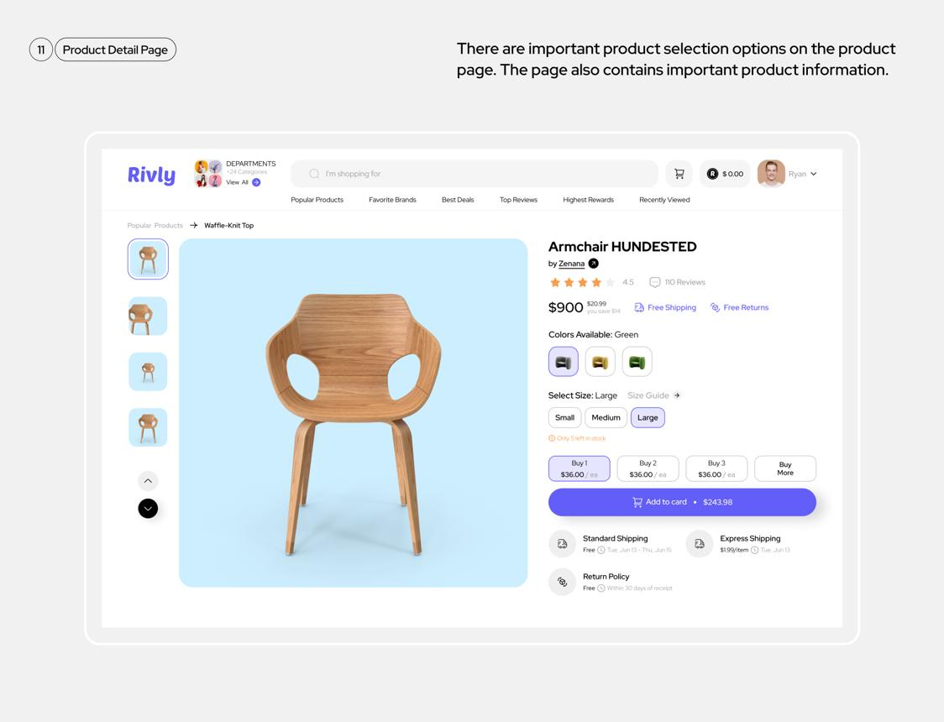
Module 3 — Product details
- Product images and image gallery.
- Product name, description, price, and discount.
- Stock availability and quantity selector.
- Ratings, reviews, and related products.
- Add to cart and add to wishlist.
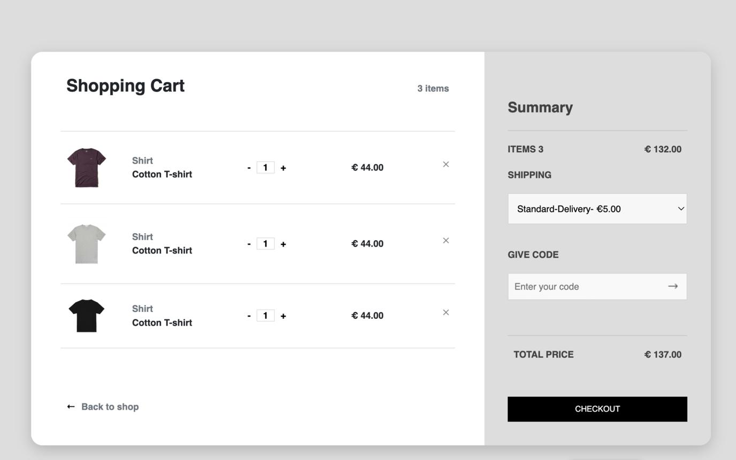
Module 4 — Shopping cart
- Add and remove products.
- Increase or decrease quantities.
- Display subtotal, discount, shipping, and total.
- Apply valid coupon codes.
- Preserve the cart between visits where appropriate.
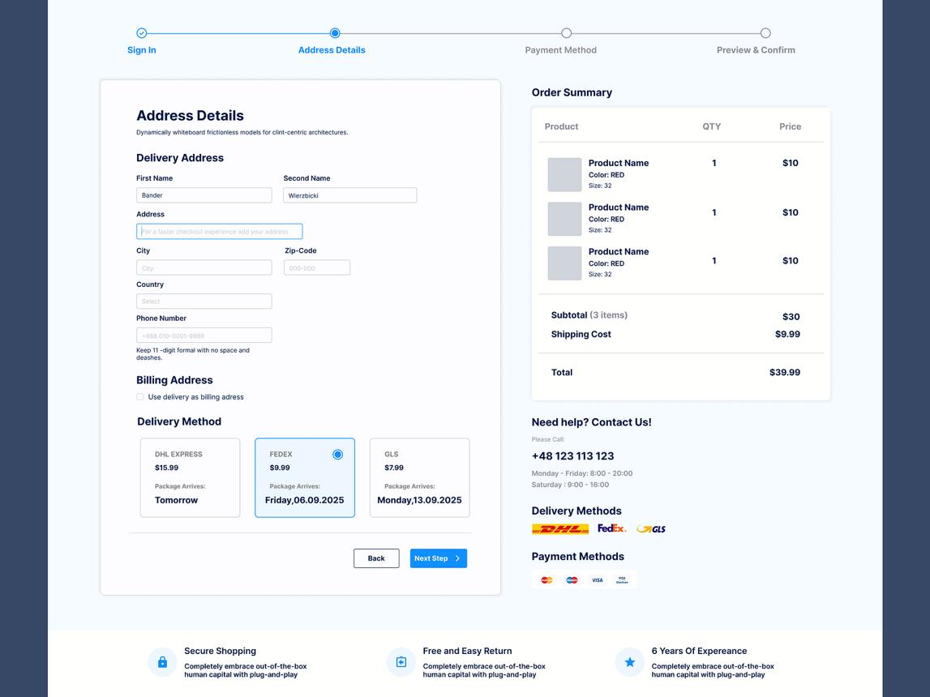
Module 5 — Checkout
- Customer contact and delivery address.
- Order summary and shipping information.
- Cash on delivery option.
- Optional online payment gateway integration.
- Order confirmation and order number.
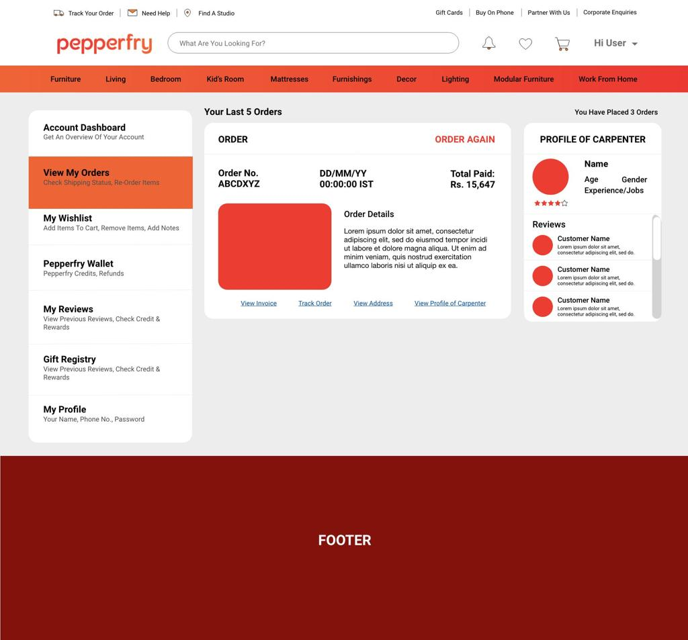
Module 6 — Customer account
- Registration, login, and logout.
- Profile and saved addresses.
- Order history and order details.
- Wishlist management.
- Password change and account settings.
4. Admin panel modules
The admin panel should use its own layout, navigation sidebar, dashboard cards, and management tables. It can be accessed through a separate route or a dedicated HTML page.
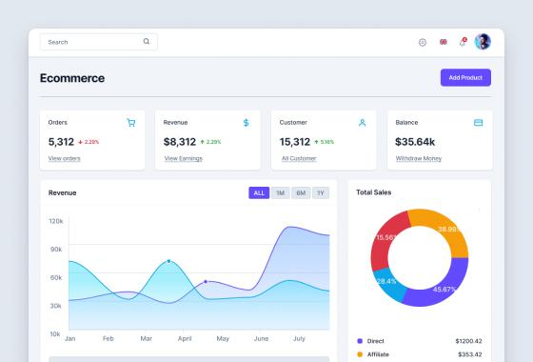
1. Dashboard
- Total products, orders, customers, and sales.
- Revenue summaries and order statistics.
- Recent orders and low-stock products.
- Charts for sales over time.
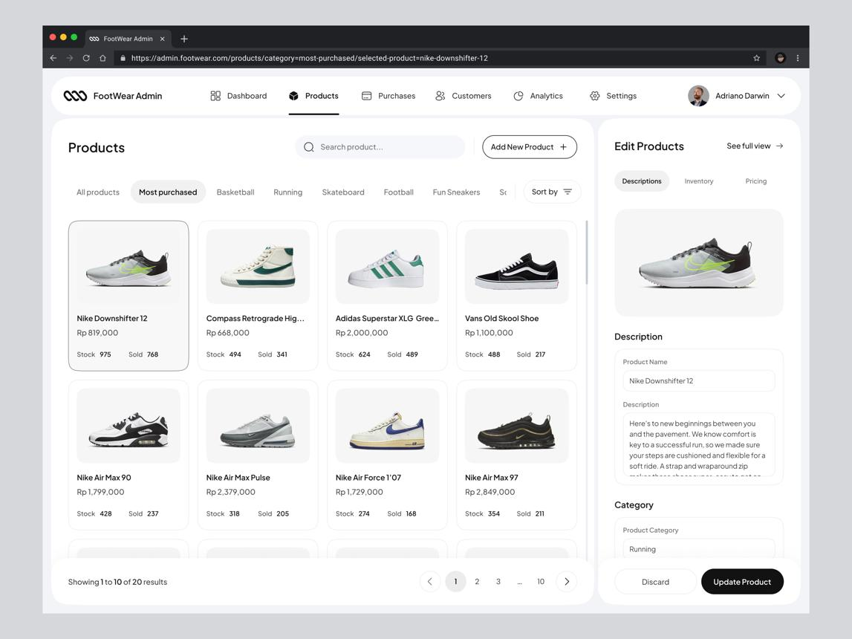
2. Product management
- Add new products with images and descriptions.
- Edit prices, discounts, and stock quantities.
- Activate or deactivate products.
- Delete products with confirmation.
- Search, filter, and sort the product table.
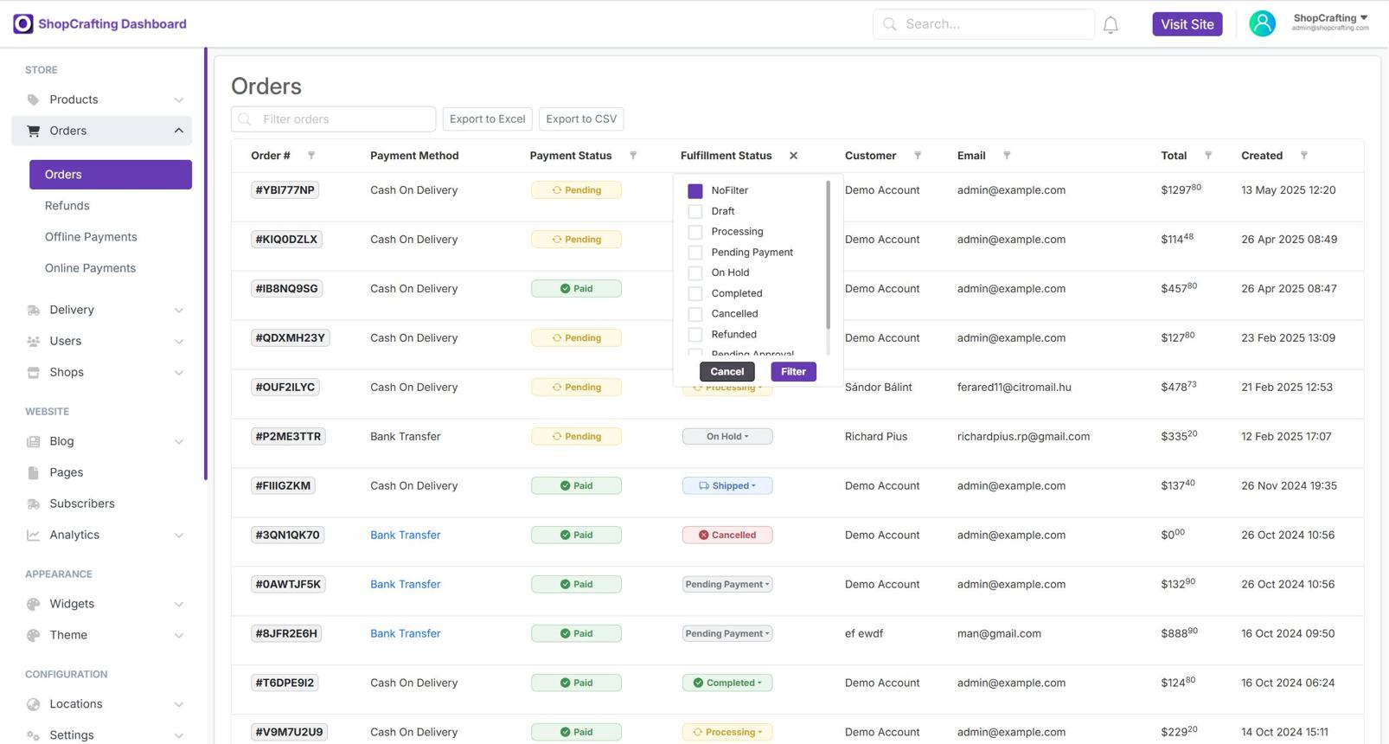
3. Order management
- View all customer orders.
- View products, quantities, addresses, and totals.
- Update order status.
- Track payment status.
- Cancel eligible orders and record refunds where supported.
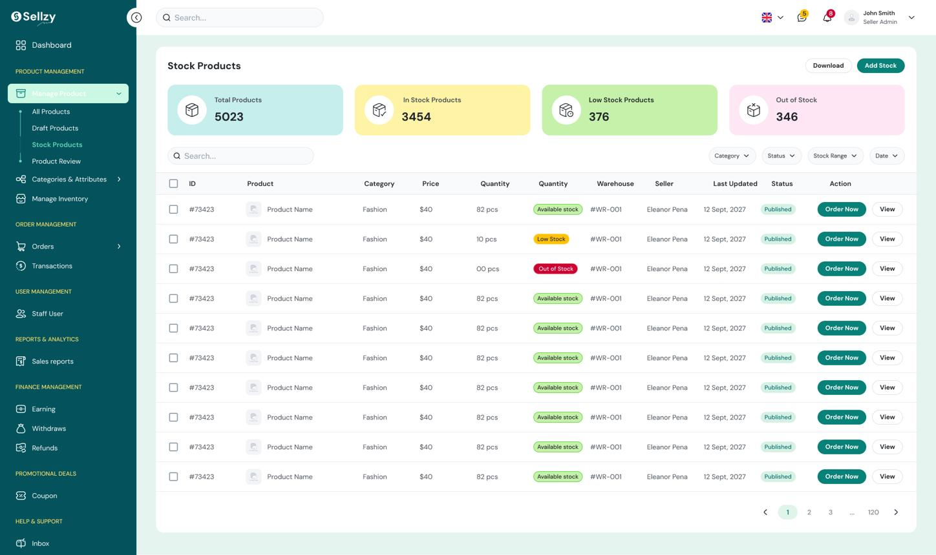
4. Inventory management
- Manage stock quantities.
- Display low-stock warnings.
- Track stock changes.
- Prevent orders from exceeding available stock.
Additional admin modules:
Module | Responsibilities
Categories | Create, edit, and organize categories
Customers | View customer records and account status
Coupons | Configure discounts, expiry dates, and usage limits
Reviews | Moderate reviews and reported content
Reports | Filter sales and order summaries and export CSV reports
Store settings | Manage store information, shipping rules, and tax settings
Admin profile | Manage admin account and security settings
5. Complete website page list
Customer pages | Admin pages
index.html — Home | login.html — Admin login
shop.html — Shop | dashboard.html — Overview
category.html — Category | products.html — Products
product-details.html — Product | add-product.html — Add product
cart.html — Cart | categories.html — Categories
checkout.html — Checkout | orders.html — Orders
order-success.html — Confirmation | order-details.html — Order details
login.html — Login | customers.html — Customers
register.html — Register | inventory.html — Inventory
wishlist.html — Wishlist | coupons.html — Coupons
my-account.html — Profile | reviews.html — Reviews
my-orders.html — Orders | reports.html — Reports
order-details.html — Tracking | settings.html — Settings
Shared components should include the header, footer, navigation, product cards, modals, alerts, loading indicators, and pagination.
6. Recommended folder structure
NEST-Ecommerce/
│
├── index.html
├── shop.html
├── category.html
├── product-details.html
├── cart.html
├── checkout.html
├── order-success.html
├── login.html
├── register.html
├── wishlist.html
├── my-account.html
├── my-orders.html
├── order-details.html
│
├── admin/
│ ├── login.html
│ ├── dashboard.html
│ ├── products.html
│ ├── add-product.html
│ ├── categories.html
│ ├── orders.html
│ ├── order-details.html
│ ├── customers.html
│ ├── inventory.html
│ ├── coupons.html
│ ├── reviews.html
│ ├── reports.html
│ └── settings.html
│
├── assets/
│ ├── css/
│ │ ├── style.css
│ │ ├── responsive.css
│ │ ├── components.css
│ │ └── admin.css
│ │
│ ├── js/
│ │ ├── config.js
│ │ ├── common.js
│ │ ├── products.js
│ │ ├── search.js
│ │ ├── cart.js
│ │ ├── wishlist.js
│ │ ├── checkout.js
│ │ ├── auth.js
│ │ ├── account.js
│ │ ├── orders.js
│ │ └── admin/
│ │ ├── dashboard.js
│ │ ├── products.js
│ │ ├── categories.js
│ │ ├── orders.js
│ │ ├── customers.js
│ │ ├── inventory.js
│ │ └── reports.js
│ │
│ └── images/
│ ├── logo/
│ ├── banners/
│ ├── products/
│ └── categories/
│
├── README.md
└── .gitignore
All frontend files remain plain HTML, CSS, and JavaScript. The JavaScript modules above are ordinary .js files, not framework components.
7. MongoDB database design
MongoDB Atlas will hold the persistent application data. The following collections are recommended.
Collection | Important fields
users | name, email, password hash reference, role, phone, status
products | name, slug, description, price, discount, images, stock, category ID
categories | name, slug, description, image, status
carts | user ID, product IDs, quantities, updated date
wishlists | user ID, product IDs, creation date
orders | user ID, items, delivery address, totals, order status
payments | order ID, payment method, amount, transaction reference, status
reviews | user ID, product ID, rating, comment, moderation status
coupons | code, discount type, value, expiry date, usage limits
inventory_logs | product ID, quantity change, reason, timestamp
settings | store information, shipping configuration, tax settings
Example product document
{
"name": "NEST Wireless Headphones",
"slug": "nest-wireless-headphones",
"description": "Wireless headphones for everyday use",
"price": 2499,
"discountPercent": 10,
"category": "electronics",
"stock": 25,
"images": [
"products/headphones-1.jpg"
],
"status": "active",
"createdAt": "2026-10-25T00:00:00Z"
}
This is an illustrative data structure. In the real database, prices and totals must be validated server-side, and product-category relationships should use stable database identifiers.
8. How the application will operate
Customer / Admin interface
HTML + CSS + Bootstrap + JavaScript
Secure database access layer
Managed JavaScript-compatible service, if supported and configured
MongoDB Atlas
Persistent application records
The customer workflow will be:
- Open the NEST homepage.
- Browse or search for a product.
- Open product details and select the quantity.
- Add products to the cart.
- Sign in and provide a delivery address.
- Confirm the order and payment method.
- Receive an order confirmation.
- View the order status in the customer account.
The admin workflow will be:
- Sign in with an authorized admin account.
- Open the dashboard.
- Add or update products and categories.
- Monitor stock and new orders.
- Update order status.
- Review customers and product feedback.
- Generate sales reports.
9. Security requirements
Even for a college project, the following security controls are important.
- Never store MongoDB usernames, passwords, or privileged database keys in frontend JavaScript.
- Never treat a hidden admin page or a JavaScript role check as real authorization.
- Use secure authentication and password hashing through a supported trusted service.
- Validate prices, stock, coupon eligibility, and order totals in a trusted server-side or managed environment.
- Protect customer information and restrict access to each user's orders.
- Use HTTPS for production.
- Prevent duplicate orders and overselling stock.
- Never store raw card details in the application database.
- Use a payment gateway that verifies payment results securely.
Scope limitation: If the restriction against any additional backend or managed service is absolute, NEST can still have a complete frontend demonstration using sample products and browser storage. However, it cannot safely provide a production-ready, shared MongoDB-backed store with secure login, admin permissions, and checkout using only browser-side JavaScript.
10. Development roadmap
Phase 1
Project setup and design
Create the folder structure, typography, color palette, responsive layout, navigation, and shared UI components.
Phase 2
Customer storefront
Build home, shop, categories, product details, search, filtering, and sorting.
Phase 3
Shopping features
Implement cart, wishlist, checkout UI, form validation, and order confirmation.
Phase 4
Admin panel
Create the dashboard, product and category management, orders, customers, inventory, and reports.
Phase 5
Database integration
Configure MongoDB Atlas and the supported secure access mechanism; connect data operations and authentication.
Phase 6
Testing and deployment
Test mobile layouts, database operations, access control, checkout, error handling, and production deployment.
11. Final deliverables
The finished NEST project should include:
- Complete customer-facing website.
- Separate admin panel.
- Responsive layouts for mobile, tablet, and desktop.
- Reusable CSS and vanilla JavaScript modules.
- Product search, filters, cart, and wishlist.
- Customer account and order management interfaces.
- Product, category, customer, and order administration.
- MongoDB collection design and database integration where the required secure access service is available.
- Setup instructions, sample data, and README documentation.
- Testing checklist and deployment instructions.
Admin permissions are enforced by the trusted access layer
Checkout validates stock and order totals
Application passes mobile and desktop testing

